You’re Invited to the 2nd Nine Weeks
PARENT ENGAGEMENT WORKSHOP
RBW 20-21

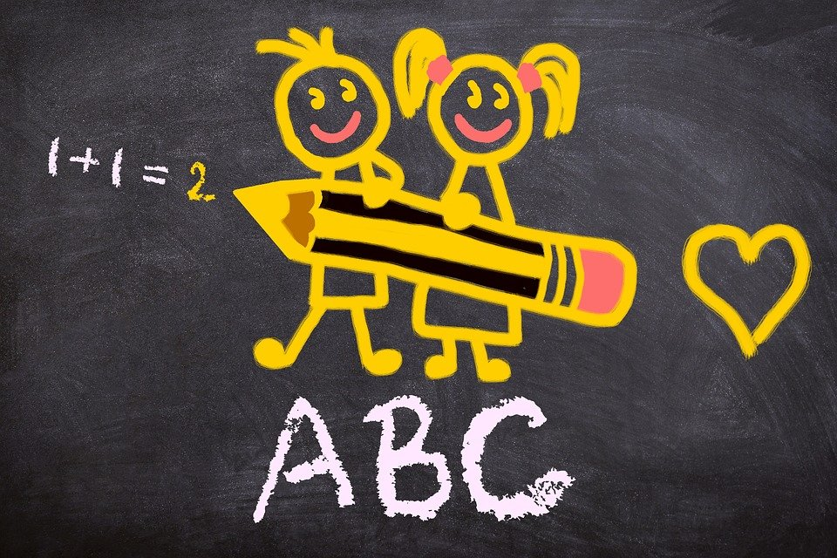

NOVEMBER 30TH, 2020
PRESENTATION WILL BE SHARED VIA REMIND
AND WEBSITE.

