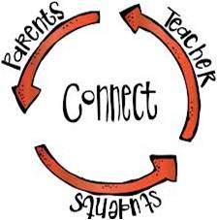
The Parent Post
Colquitt County Schools Parent and Family Engagement
August 2017
Todd Hall, Federal Programs Director, Ext. 10007,
Jeff Horne, Assistant Federal Programs Director

October 2021

Darlene Reynolds, Parent and Family Engagement Director, 10034 Yolanda Carr-Fuller, Federal Programs Secretary, 10033

Parent-Teacher Conference Tips
Parent-teacher conferences play an important role in school-home communication. The conferences are designed to increase the quality of parent-teacher communication and interaction focused on student learning and achievement. You can always contact your child’s teacher, guidance counselor or principal if you have any questions or concerns.

Things to Remember: If you’re invited to a conference, it doesn’t mean your child is in trouble! Teachers try to meet with all parents. You and the teacher both want the very best for your child. You can help your child by working together as a team.

Before the conference: Make a list of topics that you want to discuss with the teacher.

During the conference: Ask for explanations of anything you do not understand.

After the conference: Keep in touch with the teacher during the school year.

Copyright Piracy Awareness Notification
Title I, Part A, Section 1116 of the Every Student Succeeds Act (ESSA) states that Title I schools shall provide information and resources to help parents and families work with their children to understand the harms of copyright piracy. In keeping with this requirement, definitions of relevant terms as well as links to websites that may be helpful in educating children concerning copyright piracy regulations are included below:

Copyright-a form of protection given to creators and authors of literary, dramatic, musical and artistic works. A copyright means that the author has the right to do or let other do any of the following things:
- Make copies
- Distribute copies
- Perform work publicly
- Display work publicly
- Make modifications or adaptations
Generally, it is illegal for anyone to do any of the things listed above without the creator’s permission. However, there are some exceptions and limitations to this right. One major limitation is the Doctrine of Fair Use.
Copyright Piracy-Unauthorized reproduction for sale or use of a copyrighted work such as a book, lyric or software.
Online Resources:
https://youtu.be/7DOen6kDV5c
https://www.commonsensemedia.org/videos/teaching-kids-about-copyright-piracy
http://www.copyrightkids.org/

If additional assistance or more information is needed, the media specialist at your child’s school can help.

College and Career Ready Performance Index (CCRPI)
CCPRI is Georgia’s annual tool for measuring how well its schools, districts, and the state itself are preparing students for the next educational level. It provided a comprehensive roadmap to help educators, parents, and community members promote and improve the college and career readiness for all students.
GaDOE will not calculate a 2021 CCRPI summary score for the state, school districts, or schools. However, some CCPRI-related data, such as achievement rates, participation rates, and graduation rates, for example, will be calculated and publicly reported. Data will be reported through data files, Georgia Insights, and the Report Card rather than the CCRPI reporting.

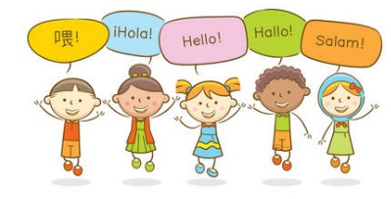
Dates to Remember

October 8, 2021 – End of 1st Quarter | January 6, 2022 – Report Cards (K-7)
October 13, 2021 – Report Cards (K-7) | January 17, 2022 – MLK Jr. Holiday
October 21-22, 2021 – Fall Break | February 18, 2022 – Student Holiday/Teacher Workday
November 22-26, 2021 – Thanksgiving Holiday | February 21, 2022 – President’s Day
December 17, 2021 – End of 2nd Quarter | March 2, 2022 – Early Release Day
December 20 – December 31, 2021 – Christmas Holidays | March 11, 2022 – End of 3rd Quarter
January 3, 2022 Student Holiday/Teacher Workday | March 17, 2022 – Report Cards (K-7)
January 4, 2022 – Classes Resume | April 4 – 8, 2022 – Spring Holidays
 | May 24, 2022 – Last Day of School
 | May 24, 2022 – Report Cards (K-7)

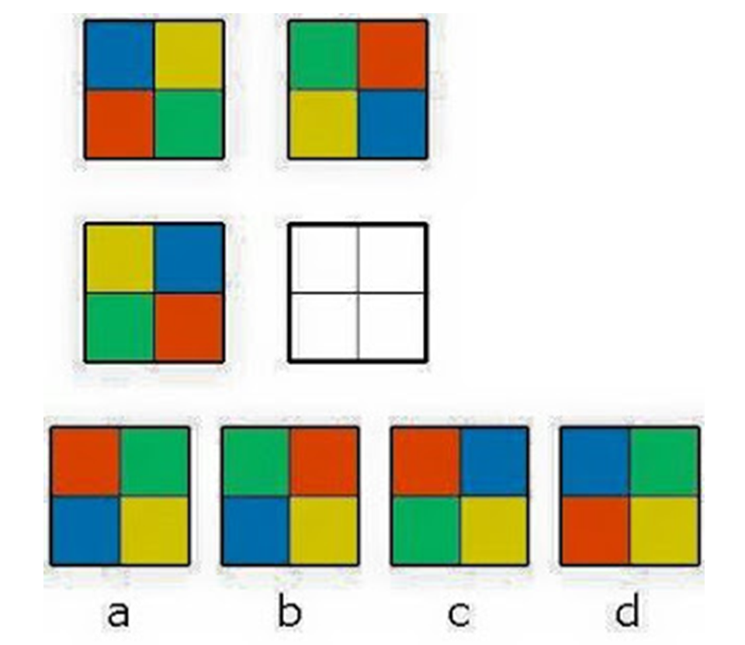
What Comes Next?
La Publicación de los Padres
Colquitt County Schools Parent and Family Engagement

Ocubre 2021
Todd Hall, Director de Programas Federales, Ext. 10007,
Jeff Horne, Subdirector de Programas Federales

Darlene Reynolds, Director de Participación Familiar, 10034 Yolanda Carr-Fuller, Secretario de Programas Federales, 10033
Notificación de Conocimiento de Piratería de Derechos de Autor
El Título I, Parte A, Sección 1116 de la Ley de Cada Estudiante será Exitoso (ESSA-por su sigla en Inglés) establece que las escuelas del Título I proporcionarán información y recursos para ayudar a los padres y familias a trabajar con sus hijos para entender los daños de la piratería de derechos de autor. Para mantener este requisito, las definiciones de los términos pertinentes, así como los enlaces a sitios web que pueden ser útiles para educar a los/as niños/as en relación con las regulaciones de piratería de derechos de autor, se incluyen a continuación.

Derechos de Autor (Copyright): una forma de protección dada a los creadores y autores de obras literarias, dramáticas, musicales y artísticas. Un derecho de autor significa que el autor tiene el derecho de hacer o dejar que otros hagan cualquiera de las siguientes cosas:
- Hacer Copias
- Distribuir copias
- Realizar trabajos públicamente
- Exhibir trabajos públicamente
- Realizar modificaciones o adaptaciones
Generalmente, es ilegal que cualquier persona haga cualquiera de las cosas enumeradas arriba sin el permiso del creador. Sin embargo, hay algunas excepciones y limitaciones a este derecho. Una limitación importante es la Doctrina del Uso Justo.
Piratería de Derechos de Autor (Copyright Piracy)- Reproducción no autorizada para la venta o uso de una obra protegida por derechos de autor como un libro, una letra o un programasoftware.

Recursos en Línea:
https://youtu.be/7DOen6kDV5c
https://www.commonsensemedia.org/videos/teaching-kids-about-copyright-piracy
http://www.copyrightkids.org/

Si necesita ayuda adicional o más información, el/la bibliotecario/a en la escuela de su niño/a puede ayudar.

Tips para Padre-Maestro
Las conferencias de padres y maestros juegan un papel
importante en la comunicación entre la escuela y el hogar.
Las conferencias están diseñadas para aumentar la
calidad de la comunicación e interacción entre padres y
maestros enfocada en el aprendizaje y el rendimiento de
los estudiantes. Siempre puede comunicarse con el
maestro, el consejero escolar o el director de su hijo si
tiene alguna pregunta o inquietud.

Cosas para recordar: Si te invitan a una conferencia, ¡no
significa que tu hijo esté en problemas! Los maestros
intentan reunirse con todos los padres. Tanto usted como
el maestro quieren lo mejor para su hijo y pueden trabajar
en equipo.

Antes de la conferencia: Haga una lista de los temas que
desea discutir con el maestro.

Durante la conferencia: Pida explicaciones sobre
cualquier cosa que no comprenda.

Índice de rendimiento de preparación universitaria y profesional (CCRPI)
CCPRI es la herramienta anual de Georgia para medir qué tan bien sus escuelas, distritos y el estado mismo están preparando a los estudiantes para el próximo nivel educativo. Proporcionó un guia integral para ayudar a los educadores, padres y miembros de la comunidad a promover y mejorar la preparación universitaria y profesional de todos los estudiantes.
El Departamento de Educación de GA no calculará un puntaje resumido de CCRPI de 2021 para el estado, los distritos escolares o las escuelas. Sin embargo, algunos datos relacionados con el CCPRI, como las tasas de logros, las tasas de participación y las tasas de graduación, por ejemplo, se calcularán e informarán públicamente. Los datos se informarán a través de Georgia Insights y Report Card en lugar de los informes CCRPI.
Fechas para Recordar
October 8, 2021 – Fin del 1er Trimestre | January 6, 2022 – boletín de notas (K-7)
October 13, 2021 – boletín de notas (K-7) | January 17, 2022 – MLK Jr. Día festivo
October 21-22, 2021 – Descanso de otoño | February 18, 2022 – Vacaciones de los estudiantes / Día de trabajo del profesor
November 22-26, 2021 – Feriado de Acción de Gracias | February 21, 2022 – Día del Presidente
December 17, 2021 – Fin del 2º Trimestre | March 2, 2022 – Día de lanzamiento anticipado
December 20 – December 31, 2021 – Vacaciones de Navidad | March 11, 2022 – Fin del 3er Trimestre
January 3, 2022 Vacaciones de los estudiantes / Día de trabajo del profesor | March 17, 2022 – boletín de notas (K-7)
January 4, 2022 – Reanudar clases | April 4 – 8, 2022 – Vacaciones de primavera
 | May 24, 2022 – Último día de colegio
 | May 24, 2022 – boletín de notas (K-7)

¿Qué viene después?

