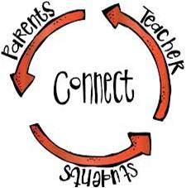
The Parent Post
Colquitt County Schools Parent and Family Engagement
August 2017
Todd Hall, Federal Programs Director, Ext. 10007,
Jeff Horne, Assistant Federal Programs Director

2nd Quarter 2020-2021

Darlene Reynolds, Parent and Family Engagement Director, 10034 Yolanda Carr-Fuller, Federal Programs Secretary, 10033

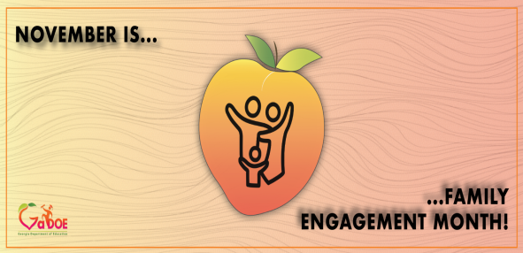
Every child in Georgia's public schools will have many teachers before they walk across the stage on graduation day. They'll learn about reading, math, science, art, and so much more. They'll learn how to interact with others. They'll learn about life. But a child doesn't meet their first teacher inside a school building - they meet them inside their home. Parents and families have an immense, lasting, and irreplaceable impact on a child's education. The month of November is Family Engagement Month in the state of Georgia, a time to collectively recognize and honor the contributions of parents and families to student success…..
State School Superintendent Richard Woods

Parent Guide: Who's Who at Your Child's School
Introduction
There are many people at your child's school who are there to help your child learn, grow socially and emotionally, and navigate the school environment. Here's a selected list of who's who at your school: the teaching and administrative staff as well as organizations at the district level. You might want to keep this list handy all year long.
In the Classroom
Subject-Area Teacher: Around fourth grade, students begin having different teachers for each subject in middle school. Middle and secondary school teachers specialize in a specific subject, such as English or history, or even career-oriented ones like cooking or automotive repair. Whenever you have a concern about your child's academic progress, you should seek out the teacher or teachers involved.
Special Education Teacher: Special education teachers help children with learning disabilities and their families over an entire academic career, starting with the IEP, which sets personalized learning outcomes. They work closely with general education teachers to coordinate students' individualized educational experience and develop specific steps to prepare the students with disabilities for middle school, high school, or, for older students, jobs or further study.
ESOL Teacher: English as a Second Language Teachers specialize in helping non-native students master English language and culture, and may also support instruction in reading and basic content knowledge, such as science or history facts. By providing English skills as well as content knowledge, ESOL courses help students join a general classroom appropriate for their age and abilities.. When you speak with your child's ESL teacher, you will learn about your child's progress with English skills as well as with mastering the content. Some ESOL teachers may be fluent in another language and culture, but it is not necessarily a requirement in order to teach English as a second language.

Support Within the School
Principal: Each school has one principal, who sets the academic and administrative expectations for the school. The principal is responsible for ensuring the school meets state, local, and federal goals on test results. Principals meet with teachers, work with staff, talk with parents, report to the school board, and, if needed, discipline students. Principals are the school's decision maker and chief public representative. You may speak with the principal about your child, such as his or her class placement, as well as about school issues that concern you.
Assistant Principal: Sometimes called vice-principals, they help the school principal by becoming primarily responsible for an administrative area of the school. Your child's school may have one or several assistant principals, depending on how many students attend. Assistant principals may handle student discipline and attendance problems, recreational programs, and health matters. For example, if your child must miss school for an extended time, perhaps because of an illness, you may work with an assistant principal to decide how your child will keep up with schoolwork and how the absence will impact your child's academic record.

Supports Within the School
Guidance Counselors: Counselors help students with social, behavioral, and personal challenges to develop the life skills to succeed. At the middle and high school levels, counselors provide increasingly more vocational and academic counseling, including helping students evaluate their own interests and abilities. High school counselors also help students plan their post-graduation experiences, by advising them about college admissions, resume writing, apprenticeships, and more. You may want to speak with the counselor about your thoughts on your child's post-graduation opportunities.
Paraprofessionals: Paraprofessionals offer support in a number of ways, often extending the individual attention that can be given to students. Middle or high school paraprofessionals may specialize in a subject, such as science or history, and may tutor, take charge of special projects, or prepare equipment, as well as monitor the cafeteria. Paraprofessionals also work with special needs children, helping them participate successfully in a general classroom.
Secretary: The school secretary manages the administrative work of the school, ranging from registering students to scheduling appointments with the principal, from answering phone calls to monitoring attendance. Frequently, a school has a secretarial team of a few people to handle all the work. When you call or visit the school, a secretary will help you reach the person you need.
Parent Coordinator: Parent coordinators (also called parent liaisons or outreach coordinators) are responsible for encouraging parental involvement in a child's education and in school activities. The parent liaison is a member of the school staff, rather than a volunteer, and is a source of support, information, and contact for parents about school policies and programs.

Support Around the School
School Board: The board is responsible for the legislative functioning of the public school district. Its members are elected, appointed, or both. The school board also oversees the budget for the district and makes district-level policy decisions. School board meetings are open to the public — check its website for a meeting schedule.

…..and so many more.
Source: https://www.colorincolorado.org/article/parent-guide-whos-who-your-childs-school

Parent Pledge
I want what is best for my child and I want my child to succeed both in school and in life. In celebration of National Parent Engagement Month, I will be an Engaged Parent by modeling positive behavior and PLEDGE TO: • Live a healthier lifestyle as a family.
• Build my child’s self esteem.
• Get to know my child’s friends.
• Make education a priority in my home

Click the link below for a Family Engagement Month Calendar

https://www.ecac-parentcenter.org/wp-content/uploads/ECAC_Elementary_FamilyEngagementCalendar_2020_final.pdf

NCFL’s guide to 30 Days of Families Learning Together provides a month’s worth of family literacy activities and practices designed to inspire family memories rooted in imagining, playing, and learning together.

http://30days.familieslearning.org/wp/wp-content/uploads/2014/10/NCFL30Days.pdf

