Parents are always welcome at Hamilton. We believe parents, teachers, and students work together to make learning successful. Listed below are a few of the opportunities for parents to join us at school during the 2019-2020 school year:

1. Parent-Student Lunches
2. Open House
3. Technology Night/Math Night- Quarter 1
4. Christmas/Academic Activity- Quarter 2
5. GMAS Info Night- Quarter 3
6. Stem Day/Night- Quarter 4
7. Parent/Teacher Conferences
8. Annual Title I Review March 2020
9. Outdoor/Garden Activities

AND MORE!!!!!

Hamilton Elementary is committed to frequent two-way communication with family about student learning. Some of the ways you can expect us to reach out to you are:

1. REMIND texts
2. Our Hamilton Webpage
3. Weekly Homework Folders or Newsletters
4. Infinite Campus
5. Parent-Teacher Conferences

Contact us with questions about your child’s progress: 229.941.5594

***Communication About Student Learning***

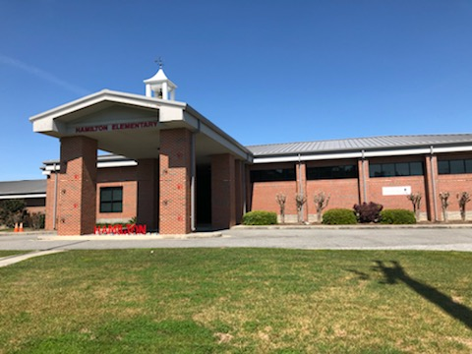

*Revised 05/15/2019*

***2019-2020***

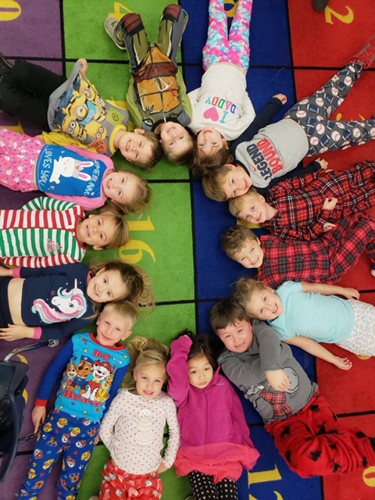

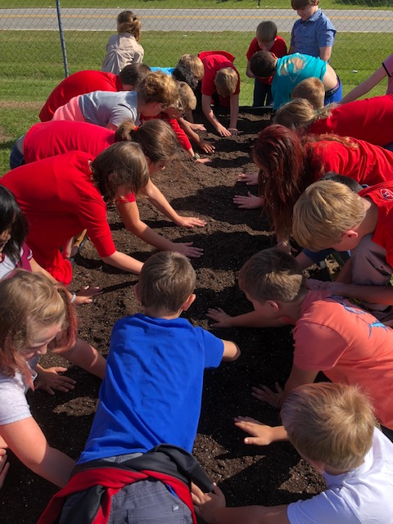

A School-Parent Compact for Achievement is an agreement between parents, students, and teachers developed together. It explains how parents and teachers will work together to help our students achieve grade-level standards.

Effective Compacts:

* Link to goals of the School Improvement Plan
* Focus on student learning skills
* Describe how teachers will help students develop those skills using high-quality instruction
* Share strategies parents can use at home
* Explain how teachers and parents will communicate about student progress
* Describe opportunities for parents to volunteer, observe, and participate in the classroom

***What is a School-Parent Compact?***

***Parents are welcome to contribute comments at any time.***

**Want to volunteer, participate, or observe in a classroom? Contact Dr. Kimberly May 229.941.5594 or kimberly.may@colquitt.k12.ga.us**

***Activities to Build Partnerships***

The parents, students, and staff of Hamilton Elementary School developed this School-Parent Compact for Achievement. Teachers suggest home learning strategies, parents added ideas to make them more specific, and students told us what would help them learn. Meetings are held each year to review the compact and make changes based upon the student needs.

***Jointly Developed***

***Hamilton Elementary School***

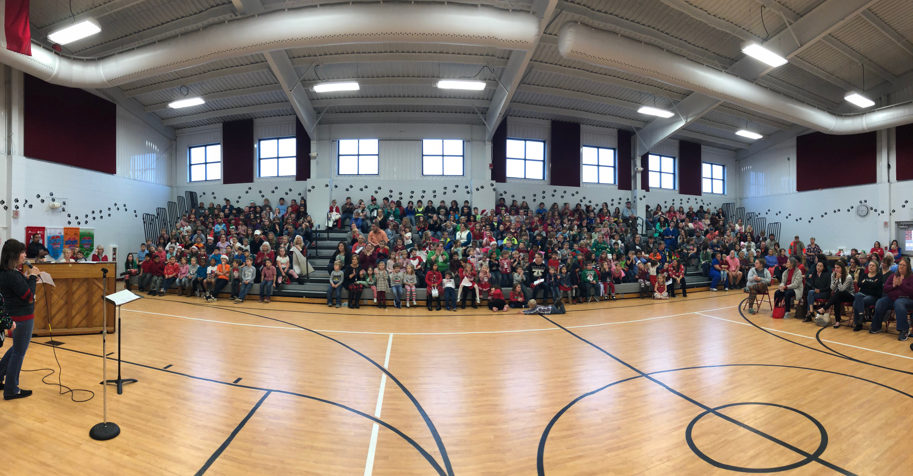

***Hamilton Elementary School Goals***

**Hamilton Elementary has chosen to focus on the following student-centered goals for the 2019-2020 school year:**

* By the end of the school year 2019-2020, there will be a decreased percentage of students that need to be remediated or monitored in the Reading or Vocabulary Domain on the State Assessment in grades 3-5.
* By the end of the school year 2019-2020, there will be an increased percentage of students scoring a three or a four in Grade 5 on the State Assessment in Social Studies.

**Colquitt County Schools has chosen to focus on the following student-centered goals for the 2019-2020 school year:**

1. Increase overall student Proficient and Distinguished Learner Levels on the GMAS EOC/EOG tests by 3%.
2. By the end of the 2019-2020 school year, the CCSS will decrease the achievement gap in proficiency between the lowest performing subgroups and highest as measured by GMAS by 3%.

***Student Responsibilities***

Hamilton School Students joined staff and parents to develop ideas about how they can succeed in school and excel academically. Students thought of the following ideas to make connections between learning at home and at school:

* Talk with my family about school every day. Share what I am learning, and go over and complete my homework.
* Attend Family Nights, or get information from the teacher or webpage if you cannot attend
* Show my family how to use Google Classrooms (age-appropriately) and use the links to practice and complete assignments
* Take home weekly newsletters and homework folders to be successful academically.

*Revised 05/15/2019*

***Family***

***Responsibilities***

**At Home:**

Hamilton School Parents joined staff to develop ideas about how families can support students’ success academically. Individual families may have other ideas to add to the list:

* Have fun with learning! Use materials students bring home from class to explore learning at home.
* Attend Family Nights, or get information from the teacher or webpage if you cannot attend
* Actively engage in using Google Classrooms (age-appropriately)
* Look for weekly newsletters, homework folders, and REMIND to help parents and students be successful academically

***Teacher/School Responsibilities:***

**In the Classroom:**

Teachers will work with students and their families to support students’ success in all academic areas. Some of our key connections with families will be:

* Provide parents with home learning activities full of materials that support what your child is learning each day
* Offer free Family Academic and Learning Support Nights this year
* Actively engage in using Google Classrooms (age-appropriately)
* Use weekly newsletters, homework folders, and REMIND to help parents and students be successful academically

***Our Goals for Student Achievement***

***Teachers, Parents, and Students—Together for Success***